NAME : YOGYAA MISHRA

REGISTRATION NO.:25BEC10043

BRANCH : ELECTRONICS AND COMMUNICATION

YEAR : 2025

COURSE CODE : CSE0001

COURSE TITLE : DIGITAL LITERACY

FACULTY NAME : KANNAN

DATE : 26.03.26

INTRODUCTION

This project focused on developing digital literacy skills through five practical tasks. In Task 1, I used a Canva-type design tool to create a visual representation explaining the concept of digital literacy. Task 2 involved setting up professional profiles on LinkedIn, GitHub, and Kaggle, which helped me understand the importance of building an online presence.
In Task 3, I solved a coding problem on HackerRank and created a Google Form, allowing me to practise both problem-solving and digital content creation. Task 4 required writing professional emails and preparing a checklist of do’s and don’ts for responsible digital literacy, which improved my communication skills. Finally, Task 5 was a case study on UPI fraud, where I analyzed how such cybercrimes occur and how they can be prevented.
Overall, this project enhanced my technical, communication, and analytical skills while making me more aware of safe and effective digital practices.

TASK 1:
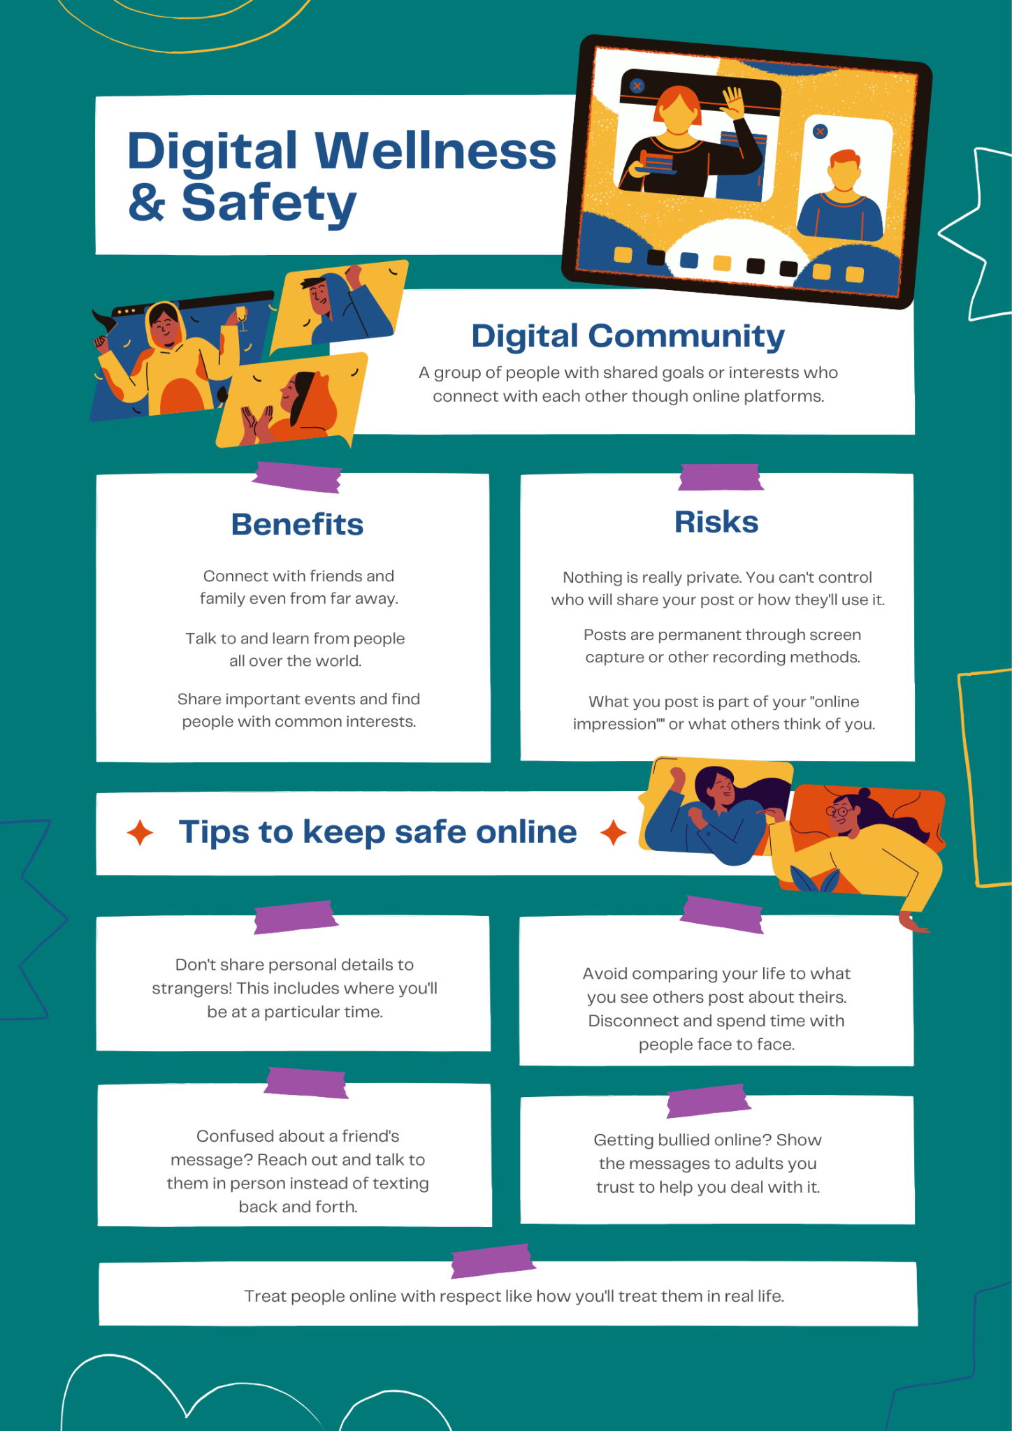
PROJECT REPORT

I created this poster using Canva, an online graphic design tool that helps in making visually appealing presentations and posters easily. My design focuses on the theme of Digital Wellness & Safety. It explains what a digital community is and highlights both the benefits and risks of interacting online. The poster shows how people can connect with friends and learn from others worldwide, while also warning about privacy issues, permanent posts, and online impressions.
Additionally, I included a section on “Tips to keep safe online,” where I suggested simple practices like not sharing personal information, avoiding comparison with others, talking in person to clear misunderstandings, and reporting online bullying to trusted adults. The overall design uses colorful illustrations and clear sections to make the information easy to understand.
One thing I found interesting while making this was how Canva offers many templates and elements that make designing easier and more creative. However, I found it a bit difficult to arrange all the text neatly without making the poster look crowded. This project helped me learn both design skills and the importance of online safety.

TASK 2 :

LINKEDIN :
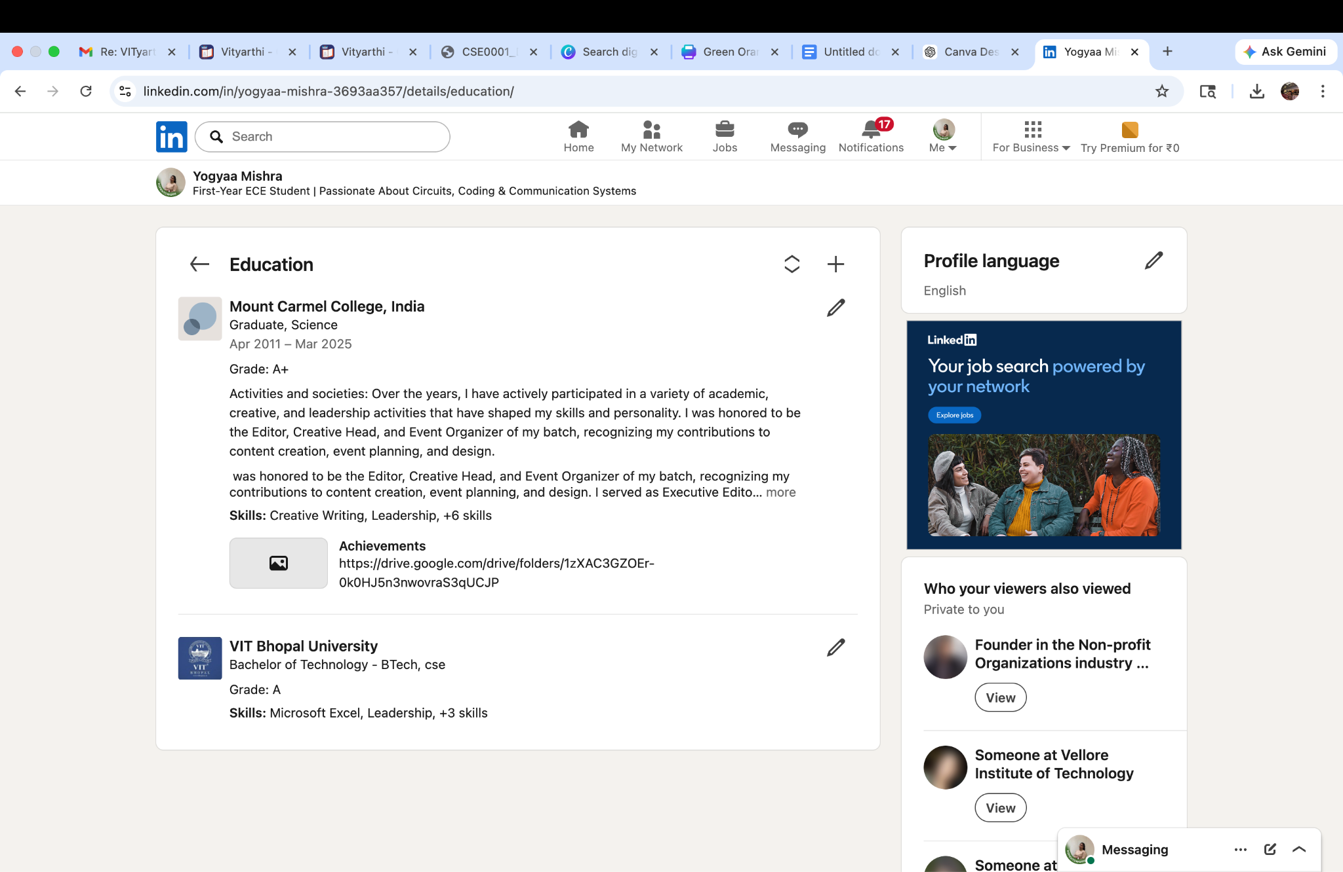

GITHUB:

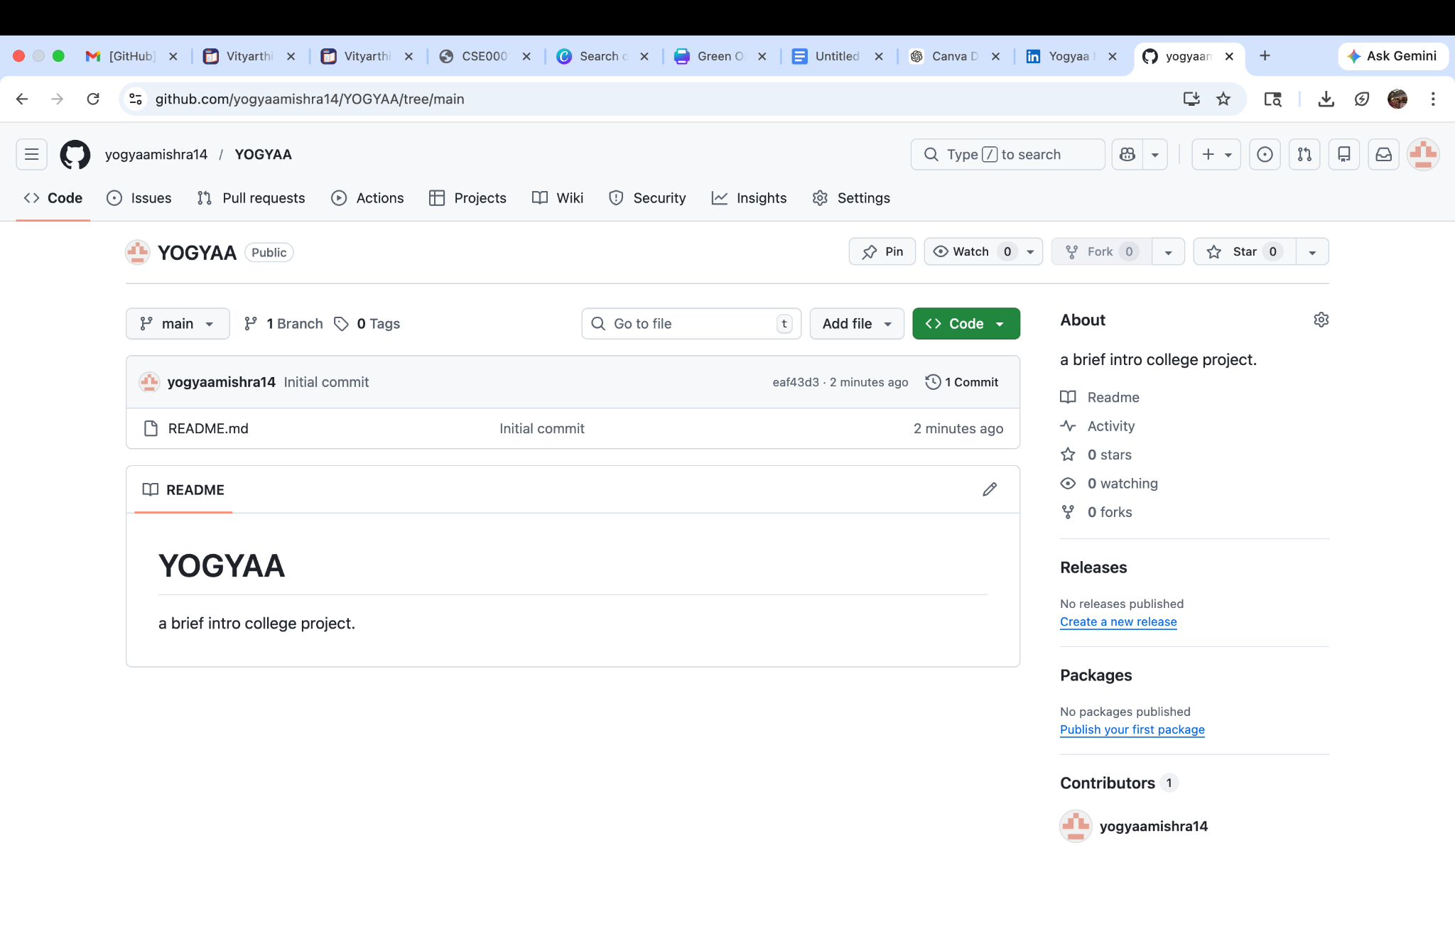
KAGGLE:

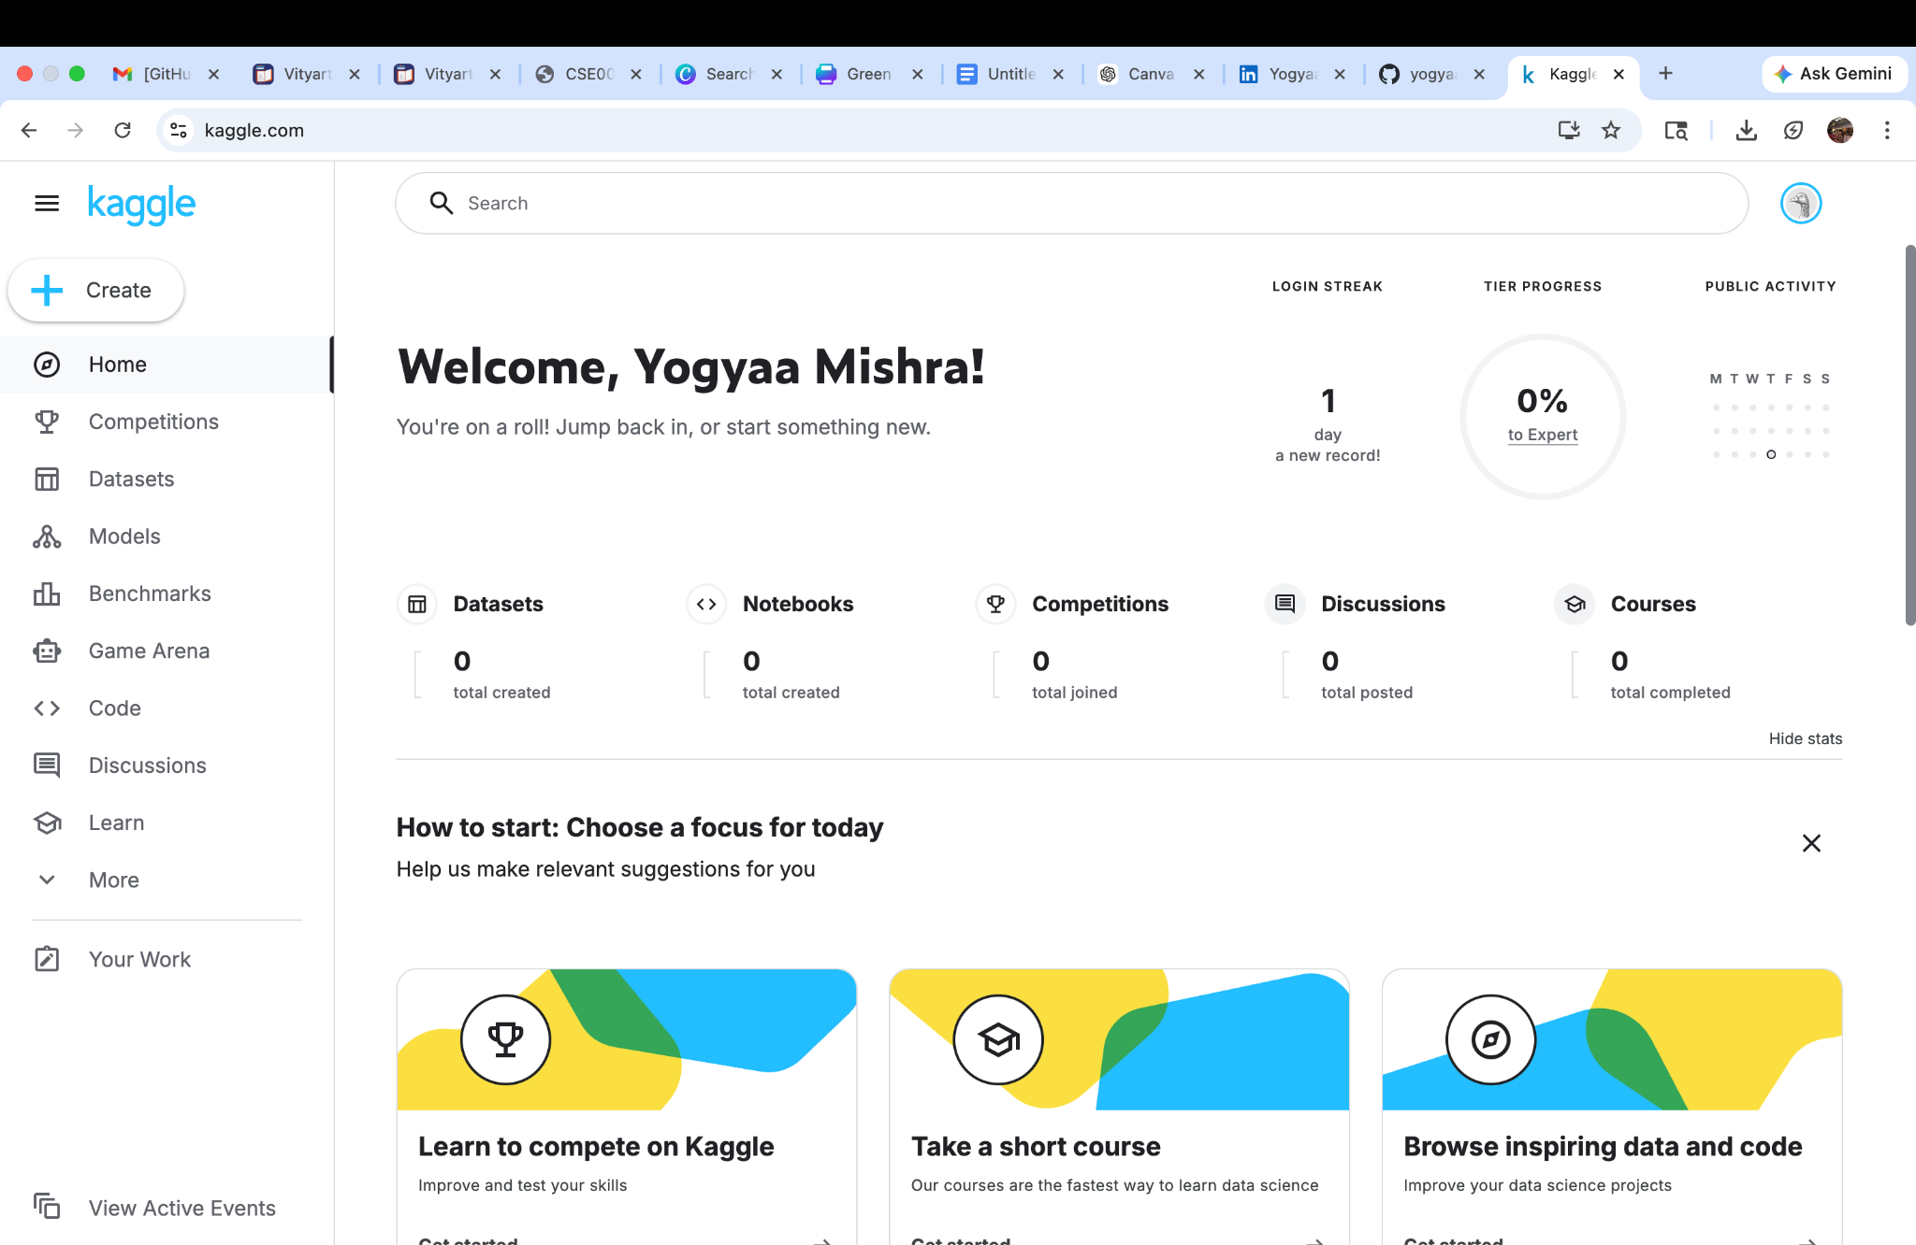

TASK 3:

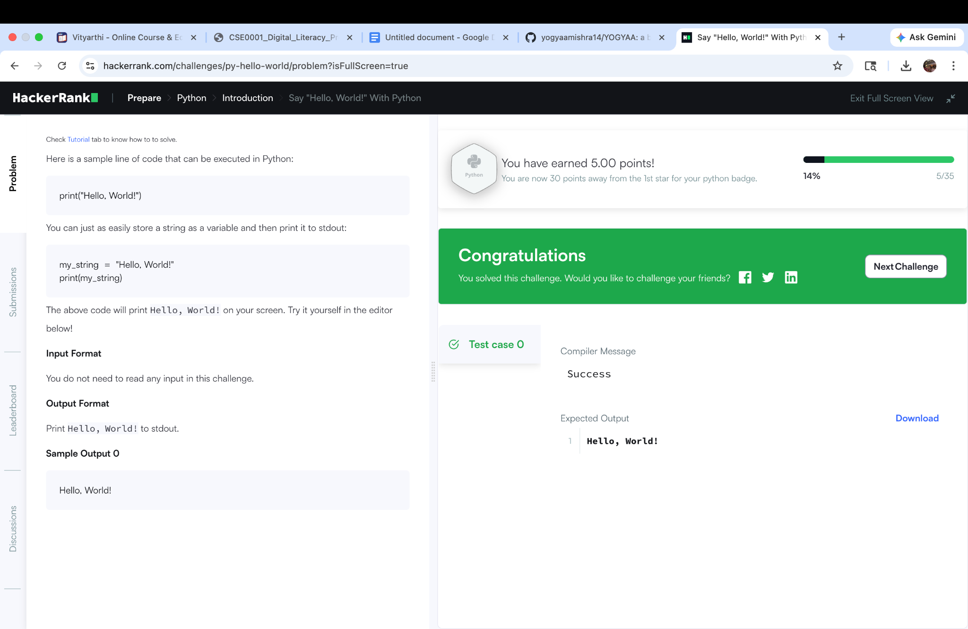

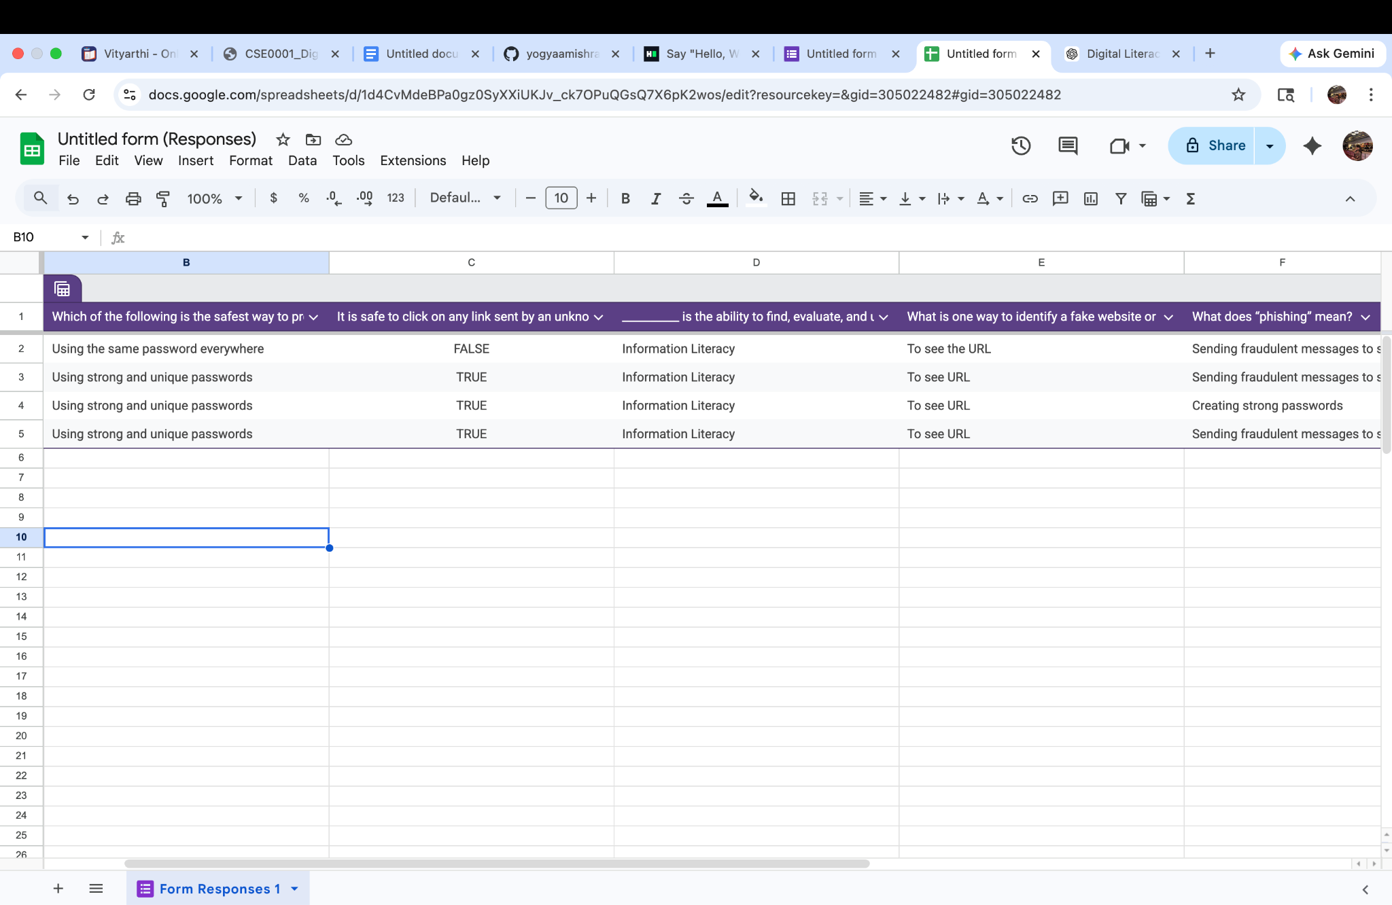

In this project, I used platforms like Google Forms and ChatGPT to complete my work. Google Forms helped me design and create an interactive quiz in a simple and organized way. I was able to add different types of questions such as multiple-choice and short answer, which made the quiz more engaging and useful for learners. ChatGPT assisted me in generating ideas, framing questions, and improving the overall structure of my quiz.
Through this project, I practised digital skills such as content creation, question design, and using online tools effectively. I also learned how to present information clearly and make it accessible to others. These platforms made the process faster and more efficient.
These tools will be very helpful in my academic journey. Google Forms can be used for creating surveys, collecting data, and conducting assessments, while ChatGPT can support learning by explaining concepts and helping with assignments. Overall, this experience improved my digital literacy and confidence in using modern educational tools.

TASK 4:
PART 1
EMAIL - 1

Dear Sir/Madam,
I hope you are doing well. I am writing to respectfully request an extension for the upcoming assignment submission. Due to unforeseen circumstances, I have been unable to complete the work to the best of my ability within the given deadline.
I value the quality of my submissions and would like to ensure that I can provide work that reflects my understanding of the subject. Therefore, I kindly request an extension of a few days to complete the assignment properly.
I apologize for any inconvenience caused and assure you that I will make the best use of the additional time granted. I would be grateful for your consideration of my request.
Thank you for your understanding.
Yours sincerely,
Yogyaa Mishra

EMAIL-2

Dear Sir/Madam,
I hope this message finds you well. I am writing to express my interest in a summer internship opportunity at your esteemed organization. I am currently a student pursuing my studies and am eager to gain practical experience in a professional environment.
I am particularly interested in developing my skills and applying my academic knowledge to real-world projects. I am a quick learner, dedicated, and enthusiastic about contributing positively to your team.
I would be grateful if you could provide me with information regarding available internship positions and the application process. I have attached my resume for your consideration.
Thank you for your time and consideration. I look forward to your response.
Yours sincerely,
Yogyaa Mishra
77XXXXXXXX

PART - 2
DO’S | DON’TS
Think before you post | Don’t overshare personal information
Protect your privacy | Don’t engage in cyberbullying
Verify information | Don’t believe everything online
Be respectful | Don’t waste too much time
Use it productively | Don’t post inappropriate content

A situation where poor digital communication caused a real problem can be seen in group projects. For example, a team of students was working on an assignment but relied only on short text messages in a chat group. One member misunderstood the deadline and submitted their part late, which affected the entire group’s grade. The lack of clear instructions and confirmation led to confusion and miscommunication.
This problem could have been avoided by using clearer communication methods. The group could have shared detailed instructions, confirmed deadlines with all members, and used tools like shared documents or scheduled online meetings. Regular updates and proper coordination would have ensured that everyone was on the same page. This shows the importance of clear, timely, and effective digital communication in avoiding misunderstandings.

TASK 5 :
PART 1:
Online/UPI payment fraud is a common cybercrime where fraudsters trick individuals into transferring money through digital payment platforms. One realistic scenario involves a scammer posing as a bank representative or customer support agent.
First, the fraudster contacts the victim through a phone call, SMS, or social media, claiming there is an issue with their bank account or offering a reward or refund. Next, they build trust and urgency, convincing the victim to act quickly. The scammer then asks the victim to share sensitive details such as OTPs (One-Time Passwords), UPI PINs, or to click on a malicious link. In some cases, they send a “collect request” on UPI apps and trick the victim into approving it, believing they will receive money instead. Once the victim authorizes the transaction, money is instantly transferred to the fraudster’s account.
Such scams usually target students, elderly people, and individuals unfamiliar with digital payments. The consequences include financial loss, emotional stress, and sometimes leakage of personal data.
This crime can be prevented by never sharing OTPs or PINs, verifying unknown callers, and carefully checking UPI requests before approving them. Awareness and cautious digital behavior are key to avoiding such frauds.

PART 2 :

🛡️ Stay Safe Online – Checklist for College Students (India)
✅ Use strong passwords – Create unique passwords with a mix of letters, numbers, and symbols for each account.
✅ Enable two-factor authentication (2FA) – Add an extra layer of security to email, social media, and banking apps.
✅ Do not share OTPs or PINs – Banks and apps never ask for these details.
✅ Verify links before clicking – Avoid suspicious links from unknown emails, messages, or social media.
✅ Keep apps and devices updated – Regular updates fix security vulnerabilities.
✅ Be careful on public Wi-Fi – Avoid logging into banking or personal accounts on unsecured networks.
✅ Limit personal information online – Don’t share address, phone number, or college ID publicly.
✅ Download apps only from trusted sources – Use official app stores like Google Play Store or Apple App Store.

💳 UPI / Financial Safety Tips:
✅ Check UPI requests carefully – Remember, you receive money without entering a PIN; entering a PIN means you are paying.
✅ Do not accept unknown collect requests – Verify the sender before approving any payment request.

🚨 Report Cyber Fraud Immediately:
- National Cyber Crime Portal: https://cybercrime.gov.in
- Helpline Number: 1930

While researching digital literacy and online safety, I was most surprised by how easily people can become victims of cyber fraud, especially UPI scams. I learned that even a small mistake, like clicking on an unknown link or approving a payment request without checking, can lead to serious financial loss. It was surprising to see how cleverly scammers create a sense of urgency and trust to trick users.
As a result of this project, one habit I will personally change is being more cautious while using digital platforms, especially for payments. I will always double-check UPI requests and never share sensitive information like OTPs or PINs. I will also be more mindful of the links I click and the information I share online. This project has made me more aware and responsible in my digital behavior.

CONCLUSION

In conclusion, this project provided valuable hands-on experience in understanding and applying digital literacy skills. Through various tasks such as designing content, creating professional profiles, solving coding problems, and analyzing cybercrime cases, I was able to explore different aspects of the digital world. The project not only improved my technical and communication abilities but also increased my awareness of online safety and responsible digital behavior.
Overall, this experience has made me more confident in using digital tools effectively for academic and professional purposes. It has also highlighted the importance of staying informed, being cautious online, and continuously upgrading digital skills in today’s technology-driven world.

REFERENCES

- National Cyber Crime Portal. (n.d.). Retrieved from https://cybercrime.gov.in
- Google Safety Center. (n.d.). Stay safe online. Retrieved from https://safety.google
- Reserve Bank of India (RBI). (n.d.). Guidelines on safe digital banking practices. Retrieved from https://www.rbi.org.in
- LinkedIn. (n.d.). Retrieved from https://www.linkedin.com
- GitHub. (n.d.). Retrieved from https://github.com
- Kaggle. (n.d.). Retrieved from https://www.kaggle.com
- HackerRank. (n.d.). Retrieved from https://www.hackerrank.com
- Canva. (n.d.). Retrieved from https://www.canva.com
- OpenAI. (n.d.). ChatGPT. Retrieved from https://chat.openai.com

